

Recruitment Workflow Management System
Software Design Specification

Document ID: REP-03
Version: 1.0-RC1
Date: 2026-07-15
Group: SE20A05 Group 7
Related documents: Report index · RDS · Traceability · Issues

Record of changes
Version | Date | Type | Description
0.1 | 2026-05-28 | Added | Initial workflow-first architecture
0.9 | 2026-07-06 | Modified | Unified HR role and current service flows
1.0-RC1 | 2026-07-15 | Modified | Code-backed package, class, data, sequence and deployment design

Contents
1. Design goals and constraints
1.1 Goals
1.2 Constraints
2. Architecture and packages
2.1 Runtime packages
2.2 Shared packages
2.3 Communication rules
3. Database design
3.1 Model catalog
3.2 Data access rules
3.3 Representative queries
4. Code designs
4.1 Identity, auth and organization
4.2 Recruitment request approval
4.3 Overall plan, tasks and job posting
4.4 Candidate, CV and search pipeline
4.5 Interview schedule and invitation
4.6 Interview results, hiring decision and offers
4.7 Notifications, email and reminders
4.8 Tracking and reports
5. Cross-cutting design
5.1 Authorization
5.2 Validation and errors
5.3 Transactions and idempotency
5.4 Audit and observability
5.5 Time, files and external providers
6. Deployment design
6.1 Development topology
6.2 Required configuration groups
7. Design verification

1. Design goals and constraints

1.1 Goals
- Keep the React SPA behind one versioned HTTP Gateway.
- Keep business capabilities in independently organized NestJS TCP services.
- Enforce workflow state, ownership, plan-lock and audit effects at service boundaries.
- Persist business changes atomically where multiple records represent one decision.
- Move CV parsing, embedding, email and reminders to asynchronous workers/queues where appropriate.
- Treat AI as a CV-processing/search utility, never as hiring authority.

1.2 Constraints
- Shared PostgreSQL database for MVP services.
- Current implemented roles: ADMIN, DEPARTMENT_HEAD, HR_LEADER, CANDIDATE.
- Prisma does not model the pgvector column directly; vector DDL/query is raw SQL.
- Worker is a plain TypeScript process, not a NestJS application.
- Frontend is React/Vite SPA; no SSR/Next.js assumptions.

2. Architecture and packages
Editable package diagram: package-architecture.puml
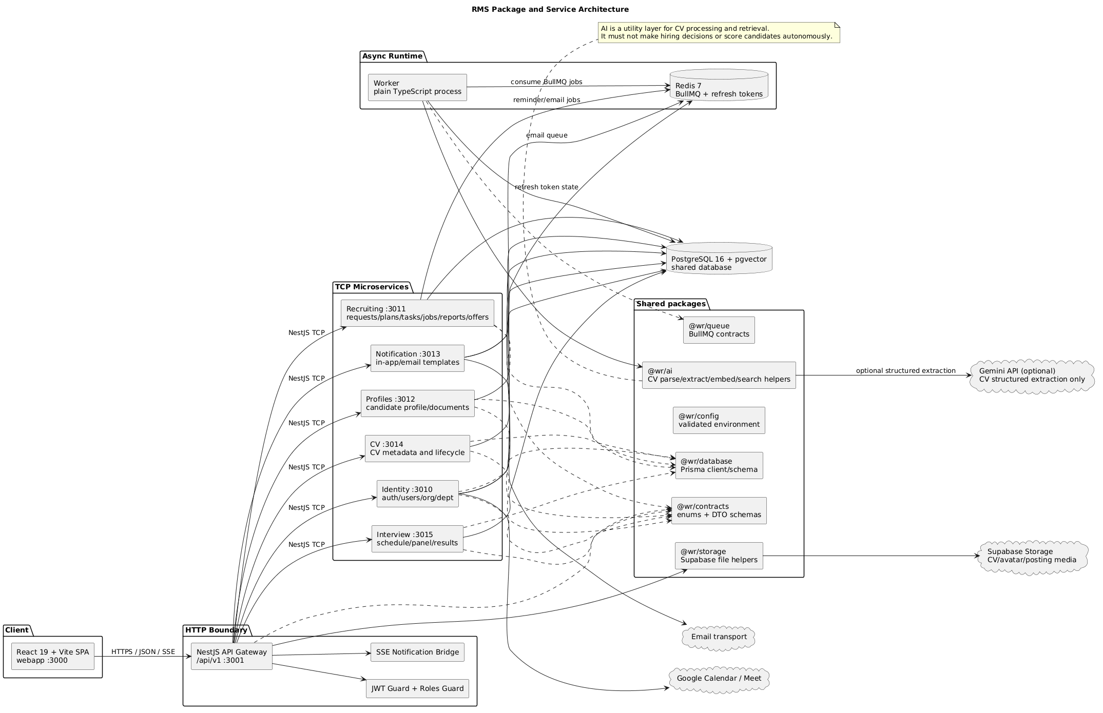
Figure: Package Architecture — editable PlantUML source linked above

2.1 Runtime packages
Package / service | Responsibility | Public boundary
webapp | React role screens, routing, form state and API client | Browser routes only
services/gateway | /api/v1, Swagger, JWT/RBAC, HTTP DTOs, TCP proxy, SSE | HTTP/SSE
services/identity | Auth, users, organizations, departments, Google Calendar | TCP
services/recruiting | Requests, plans, tasks, postings, applications, search, offers, reports | TCP
services/profiles | Candidate profile, avatar and document/evidence metadata | TCP
services/cv | Candidate CV lifecycle and processing state | TCP
services/interview | Schedule, conflict, panel, invitations and results | TCP
services/notification | Notification records, email templates and delivery commands | TCP
services/worker | BullMQ consumers for CV, embeddings, email and reminders | Redis queue

2.2 Shared packages
Package | Design rule
@wr/contracts | Shared enums, schemas and API types; intended single source of truth
@wr/database | Prisma schema/client/migrations for the shared PostgreSQL database
@wr/config | Environment validation; services fail fast on invalid required configuration
@wr/queue | Queue names, job names and payload contracts
@wr/ai | CV parse/extract/embedding/search helpers; no database ownership or hiring decision logic
@wr/storage | Supabase storage paths, upload/download/remove and signed/public URL handling
@wr/ui | Shared UI primitives/design tokens where adopted by the SPA

2.3 Communication rules
- SPA calls only Gateway /api/v1 routes.
- Gateway uses NestJS ClientProxy.send() and resolves Observables before returning HTTP responses.
- Microservice controllers use @MessagePattern() and do not expose HTTP decorators.
- Async jobs are identified by stable queue/job names and persistent record IDs.
- Domain services write status/log/side-effect intent before dispatching non-transactional external delivery.

3. Database design
Editable class/entity diagram: domain-class-diagram.puml
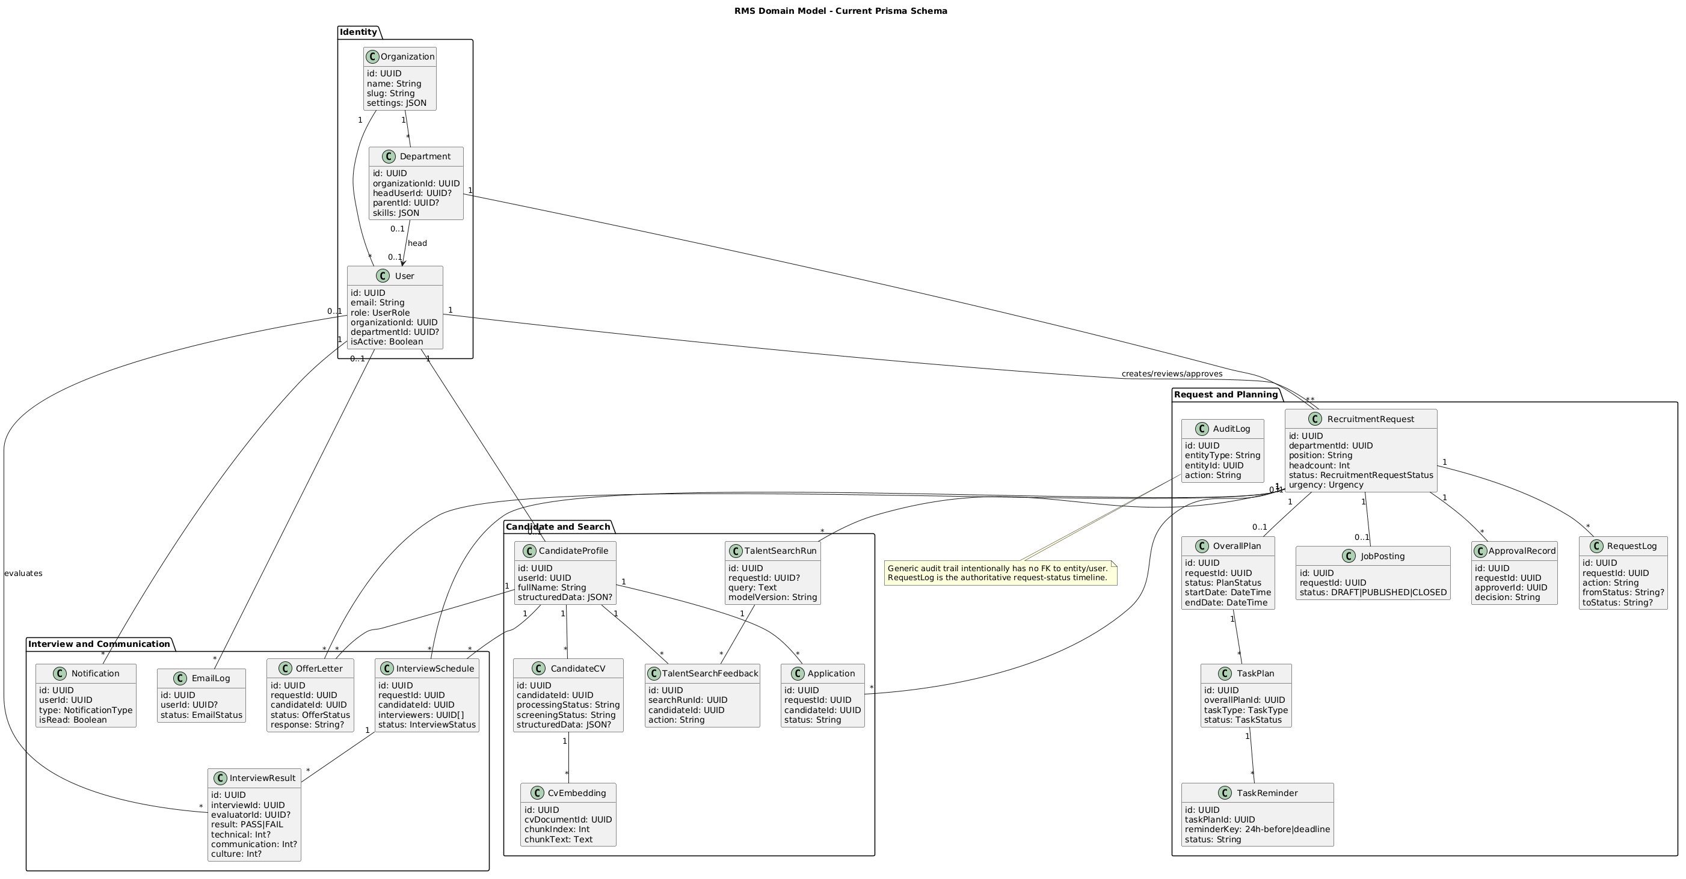
Figure: Domain Class Diagram — editable PlantUML source linked above

3.1 Model catalog
Model | Table | Purpose | Key relations
User | users | Internal/candidate identity and role | Organization, Department, requests, plans, tasks, feedback, notifications
Organization | organizations | Enterprise tenant/configuration | Users, Departments
Department | departments | Hierarchical org unit, skills and head | Organization, parent/children, Users, Requests
RecruitmentRequest | recruitment_requests | Workflow aggregate and hiring target | Department, owners, plan, posting, applications, interviews, offers, logs
JobPosting | job_postings | Publishable request-facing vacancy | One request
ApprovalRecord | approval_records | Attributable request decision | Request, approver
RequestLog | request_logs | Authoritative request timeline | Request, performed user
AuditLog | audit_logs | Generic cross-entity status/action audit | No FK by design
OverallPlan | overall_plans | Campaign timeline and approval | One request, creator/approver, tasks
TaskPlan | task_plans | Assigned campaign activity | Plan, assigned user, reminders
TaskReminder | task_reminders | Idempotent reminder window state | TaskPlan; unique task/key
CandidateProfile | candidate_profiles | Candidate identity/profile data | User, CVs, applications, interviews, offers
CandidateCV | candidate_cvs | File metadata, raw/structured data and processing state | CandidateProfile, embeddings
CvEmbedding | cv_embeddings | CV chunk text and vector row identity | CandidateCV; vector column via SQL
InterviewSchedule | interview_schedules | Candidate/request schedule and panel IDs | Request, CandidateProfile, results
InterviewResult | interview_results | Evaluator decision/scores/notes | Schedule, evaluator User
OfferLetter | offer_letters | Offer content, delivery and response | Request, CandidateProfile, generator
Notification | notifications | In-app message/read state | User
EmailLog | email_logs | Email intent/delivery/error state | Optional User
Application | applications | Candidate/request pipeline membership | Request, CandidateProfile, collector
TalentSearchRun | talent_search_runs | Search query/filter/model audit | Actor, optional request, feedback
TalentSearchFeedback | talent_search_feedback | Human action on ranked result | SearchRun, CandidateProfile, actor, request

3.2 Data access rules
- IDs are UUID strings.
- Mapped database names use snake_case; indexes and unique constraints have explicit names.
- JSON fields store flexible skills, profile extraction, attendance and metadata shapes.
- Critical multi-row transitions use prisma.$transaction.
- RequestLog must remain consistent with the request status updated by the same business action.
- Generic AuditLog accepts system/worker actors and therefore intentionally omits strict actor/entity FKs.
- Vector schema and similarity operations are raw SQL migrations/queries because Prisma does not natively own the pgvector column.

3.3 Representative queries
Prisma-style request transition:
TYPESCRIPT
await prisma.$transaction([
prisma.recruitmentRequest.update({
where: { id: requestId },
data: { status: nextStatus },
}),
prisma.requestLog.create({
data: { requestId, action, fromStatus, toStatus: nextStatus, performedById },
}),
]);

Conceptual pgvector retrieval (exact filters may vary by implementation):
SQL
SELECT cv_document_id,
chunk_text,
1 - (embedding <=> $1::vector) AS similarity
FROM cv_embeddings
ORDER BY embedding <=> $1::vector
LIMIT $2;

Tracking aggregation is implemented through Prisma queries over request relations and RequestLog; pagination/role filtering must occur before returning dashboard rows.

4. Code designs

4.1 Identity, auth and organization
Class | Key methods | Design responsibility
Gateway IdentityController | register, verifyRegister, login, refresh, logout, user/org/dept routes | HTTP validation, role guards and TCP proxy
AuthService | registration/login variants, token issue/refresh/logout, password reset | Credential/session rules, Redis refresh state
UsersService | list, get, create, update, status/role operations | User scope and active/role validation
OrganizationsService | create, list, get, update | Organization uniqueness/settings
DepartmentsService | create, list, get, update, delete | Org hierarchy, department head and scoped access
GoogleCalendarService | OAuth URL/callback, token validation, meeting creation | Optional calendar/Meet integration

Database access: User, Organization, Department; Redis refresh-token state. Passwords/tokens are never returned as general user data.

4.2 Recruitment request approval
Editable sequence: sequence-request-approval.puml
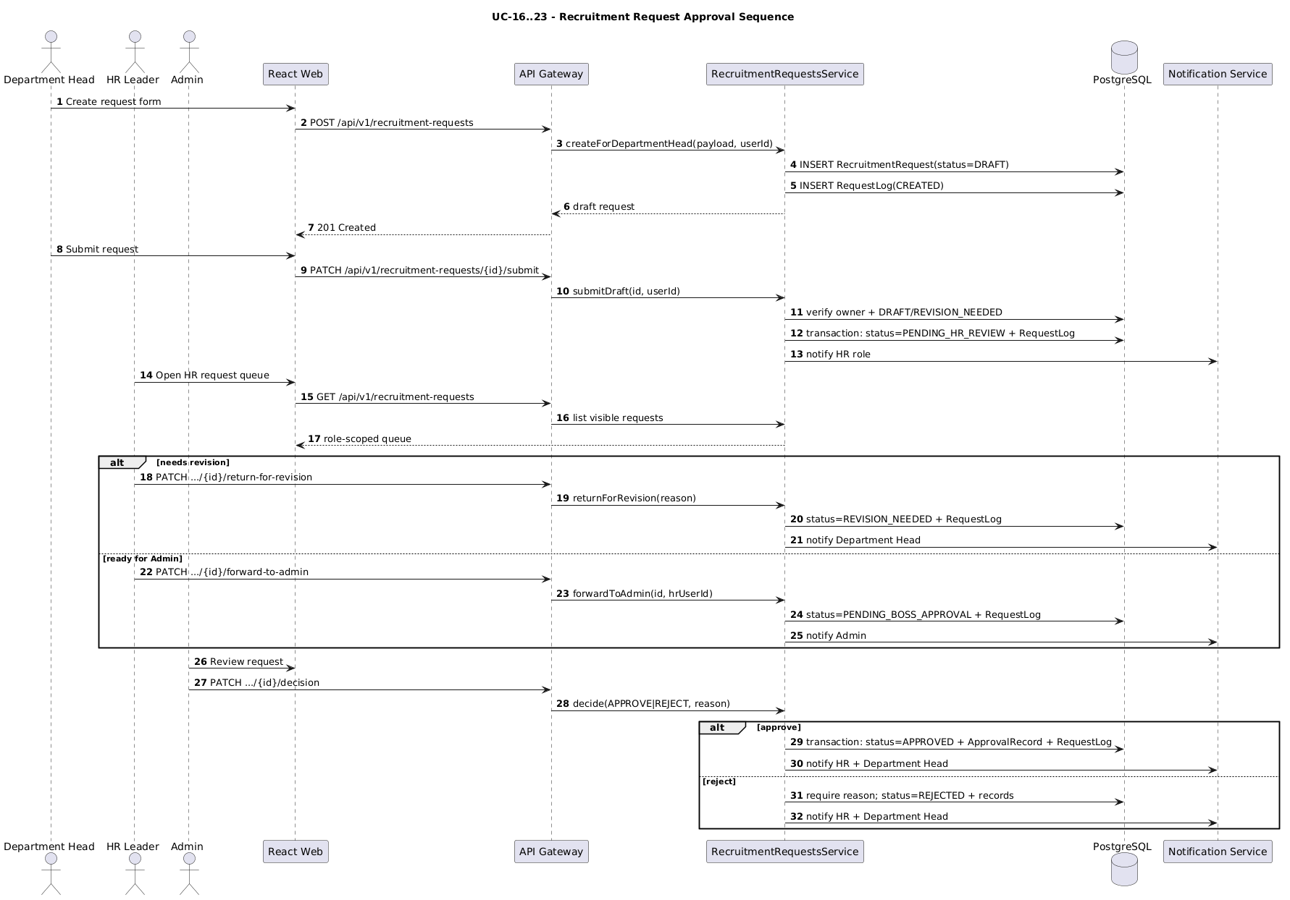
Figure: Sequence Request Approval — editable PlantUML source linked above
Class | Method | Input/output and processing
Gateway RecruitingController | request routes | Applies DEPARTMENT_HEAD, HR_LEADER, ADMIN guards and forwards current actor
RecruitmentRequestsService | createForDepartmentHead | Validates owner/department and creates DRAFT plus initial log
RecruitmentRequestsService | updateForDepartmentHead | Restricts editable state/owner and records revision response when supplied
RecruitmentRequestsService | submitDraft | Requires owner and DRAFT/REVISION_NEEDED; transactionally moves to PENDING_HR_REVIEW and logs
RecruitmentRequestsService | assignToHr | Validates HR assignee and updates ownership/log
RecruitmentRequestsService | returnForRevision | HR moves request to revision with reason and notification
RecruitmentRequestsService | forwardToAdmin | Requires HR-reviewed state and moves to boss approval
RecruitmentRequestsService | requestChanges | Admin requests attributable changes from HR/Department Head flow
RecruitmentRequestsService | decide | Approves/rejects with required state/reason, approval record, log and notifications

Database access: RecruitmentRequest CRUD, ApprovalRecord create, RequestLog create/read, Notification side effects.

4.3 Overall plan, tasks and job posting
Class | Key methods | Design responsibility
OverallPlanService | create, submit, approve, reject, resubmit, startCampaign | Timeline/state rules, required tasks, request transition and assignee notification
TaskPlanService | create, update, assignRecruiter, updateStatus, upsertTaskReminders | Date/assignee/status rules and reminder records
JobPostingsService | create, list, get, update, publish, close | Request/task permission, publication window and media metadata

startCampaign requires an approved plan and every task assigned to an active HR member with start/end dates. It transactionally sets the request to ACTIVE, writes CAMPAIGN_STARTED, then emails assignees.
Database access: OverallPlan, TaskPlan, TaskReminder, RecruitmentRequest, RequestLog, JobPosting, User.

4.4 Candidate, CV and search pipeline
Class/component | Key methods/jobs | Design responsibility
Gateway CvController | listMine, uploadMine, replaceMine, deleteMine, latest file | File validation, storage upload/rollback and TCP calls
CV CvService | upload/replace/get/list/delete and processing updates | Candidate ownership and CV lifecycle
CandidateProfilesService | getProfile, updateProfile, enrichment sync | Profile projection and latest-CV structured data
CvSearchService | search | Query embedding, vector search and role/campaign constraints
TalentSearchService | search, expandQuery, recordFeedback, updateScreeningDecision | Search audit and human feedback/actions
Worker | parse and embedding processors | Extract text/structured data, chunk and generate embeddings
@wr/ai | parse/extract/embed helpers | Pure processing utilities; no hiring decision

Upload/replace workflow:
- Gateway validates file and begins text extraction and storage upload.
- If service persistence fails, the newly uploaded object is removed.
- CV service persists current file/processing state and queues deeper processing.
- Worker stores parse result and vector chunks; failure state is visible for retry/manual review.
- Search results are recorded with model version and human feedback where applicable.
Database access: CandidateProfile, CandidateCV, CvEmbedding, Application, TalentSearchRun, TalentSearchFeedback; Supabase storage object paths.

4.5 Interview schedule and invitation
Editable sequence: sequence-plan-and-interview.puml
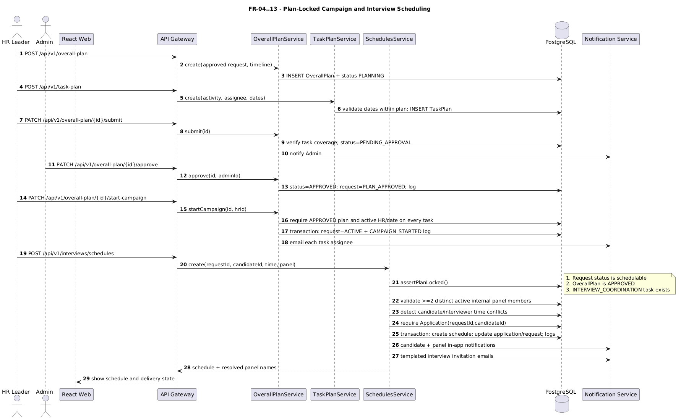
Figure: Sequence Plan And Interview — editable PlantUML source linked above
Class | Method | Input/output and processing
Gateway InterviewController | schedule/list/get/reschedule/cancel/confirm routes | HTTP DTO/role boundary and TCP proxy
SchedulesService | assertPlanLocked | Requires schedulable request, approved OverallPlan and INTERVIEW_COORDINATION task
SchedulesService | assertValidInterviewers | Deduplicates and validates minimum active internal panel
SchedulesService | detectConflicts | Checks candidate and panel time overlap
SchedulesService | create | Validates ISO date/duration, application, creates schedule and changes states/logs transactionally
SchedulesService | confirm/reschedule/cancel operations | Ownership/state/conflict/reason checks and notifications
InvitationsService | sendInvitations, getEmailLogs | Candidate/panel email composition and delivery log lookup

The create transaction inserts InterviewSchedule, changes Application and RecruitmentRequest to interviewing, and writes RequestLog. Generic audit and external notifications occur after persistence and report failures separately.
Database access: OverallPlan, TaskPlan, Application, InterviewSchedule, RecruitmentRequest, RequestLog, AuditLog, User, Notification, EmailLog.

4.6 Interview results, hiring decision and offers
Editable sequence: sequence-hiring-offer.puml
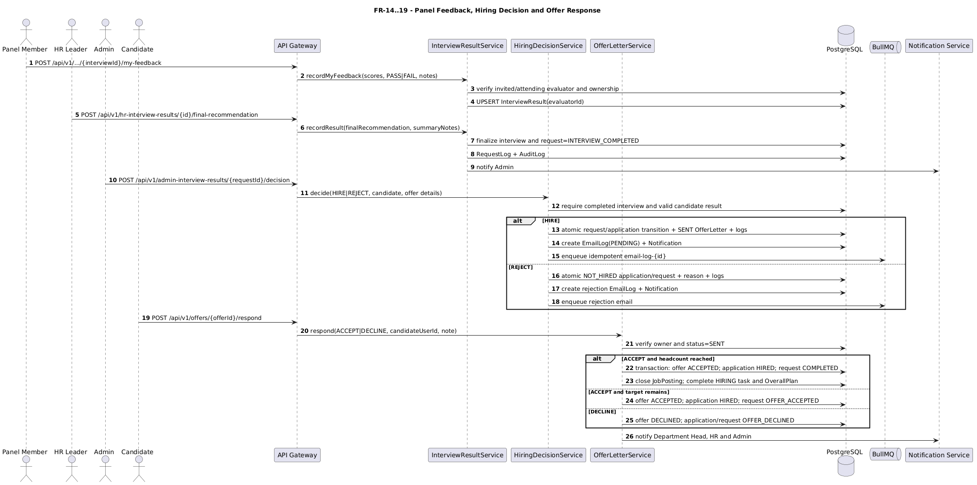
Figure: Sequence Hiring Offer — editable PlantUML source linked above
Class | Key methods | Design responsibility
InterviewResultService | listCompleted, getDetails, recordMyFeedback, saveEvaluationDraft, recordResult | Evaluator access, per-person scores, final recommendation and completion
Gateway result controllers | list/detail/feedback/recommendation | Separate Admin, HR and Department Head route scopes
HiringDecisionService | decide, requestInfo | Validate final state/candidate evidence; atomic hire/reject and communication intent
OfferLetterService | generate, get, listForCandidate, send, respond | Offer content, ownership, immutable response and completion logic

HiringDecisionService.decide updates request/application state, logs, email intent and candidate notification in one database transaction; HIRE can create a SENT offer. Delivery is then queued using persistent email-log-derived job IDs.
OfferLetterService.respond requires candidate ownership and SENT status. ACCEPT updates offer/application/request and candidate department; when accepted hires meet headcount it also closes the posting and completes the hiring task/plan/campaign. DECLINE records response and keeps the campaign available to continue.
Database access: InterviewSchedule, InterviewResult, Application, RecruitmentRequest, OfferLetter, RequestLog, Notification, EmailLog, JobPosting, TaskPlan, OverallPlan, User.

4.7 Notifications, email and reminders
Component | Responsibility
Gateway NotificationsController | SSE stream, list, mark read/delete operations
SseNotificationService | Bridges stored/published notifications to connected users
Notification service | Creates notification, renders templates and accepts email commands
Worker email processor | Sends queued email and updates EmailLog status/error
Task reminder flow | Upserts 24h-before/deadline records and skips completed/ineligible tasks

External email is not part of a database transaction. The design persists intent first, then queues delivery and records failure for retry/diagnosis.
Database access: Notification, EmailLog, TaskReminder, TaskPlan.

4.8 Tracking and reports
Class | Key methods | Output
ReportsService | getRealtimeTracking | Role-scoped owner, pending action, task/interview/offer counters and latest log
ReportsService | getHrDashboard, getAdminDashboard, getHrRequestQueueSummary | Dashboard summaries
ReportsService | getAnnualReport, getAnnualReportExport | Annual metrics and CSV/PDF-ready data
ReportsService | getDepartmentStats, getDepartmentReport | Department drill-down
ReportsService | getTimeToHireReport, getPipelineOverview, getHiringMetrics | Operational analytics

Report queries must enforce role scope before aggregation. Realtime tracking derives the timeline from RequestLog and combines request, plan/task, interview, application and offer relations.

5. Cross-cutting design

5.1 Authorization
- Global JWT protection with explicit public routes.
- Role metadata and RolesGuard at Gateway controllers.
- Service-level owner, department, actor and workflow-state validation.
- Candidate file/offer/schedule reads and mutations check ownership.
- Panel feedback checks evaluator participation/permission.

5.2 Validation and errors
- Gateway DTO/class validation rejects malformed HTTP input.
- Services return structured RPC errors with HTTP-equivalent status.
- Global exception filter normalizes HTTP responses.
- Conflict errors describe invalid state, schedule overlap or duplicate response rather than silently ignoring it.

5.3 Transactions and idempotency
- Multi-record business decisions use Prisma transactions.
- Request transitions and logs are coupled.
- Offer response may produce multiple ordered logs in one transaction.
- Reminder uniqueness is (taskPlanId, reminderKey).
- Email job IDs should derive from EmailLog IDs.
- Issue #223 is closed; CV parse/email completion guards and stable reminder/email job IDs are present. All 13 worker unit tests passed during documentation QA; a retry/concurrency execution remains a release-verification item.

5.4 Audit and observability
- RequestLog: request workflow truth.
- AuditLog: generic plan/interview/CV action trail.
- EmailLog: delivery state/error.
- TalentSearchRun/Feedback: search/model/human-action trace.
- Aggregated health endpoints are implemented.
- Issue #224 is closed and implementation evidence exists in @wr/logger, Gateway correlation middleware, TCP interceptors and BullMQ context propagation.

5.5 Time, files and external providers
- API date/time input is ISO-8601; interviews must be future times.
- User-facing schedule email currently formats Asia/Ho_Chi_Minh time.
- CV storage paths are generated and database rollback removes newly uploaded objects.
- Provider credentials come from validated environment variables and are never documented as literal secrets.
- Google Calendar/Meet, Supabase storage, email transport and optional Gemini extraction must fail with explicit user/operational feedback.

6. Deployment design
Editable diagram: deployment.puml
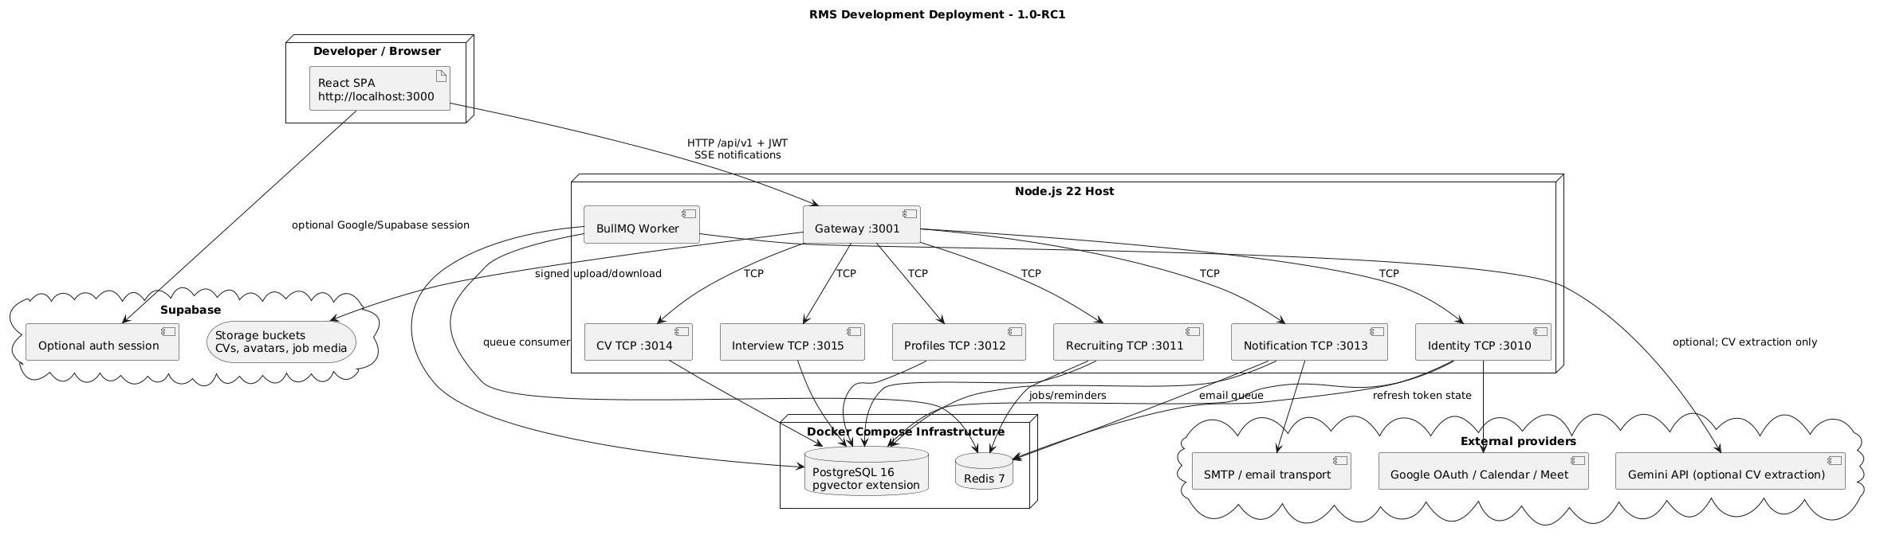
Figure: Deployment — editable PlantUML source linked above

6.1 Development topology
Component | Default address / transport
Webapp | http://localhost:3000
Gateway | http://localhost:3001/api/v1
Identity | NestJS TCP :3010
Recruiting | NestJS TCP :3011
Profiles | NestJS TCP :3012
Notification | NestJS TCP :3013
CV | NestJS TCP :3014
Interview | NestJS TCP :3015
PostgreSQL/Redis | Docker Compose/private development ports

6.2 Required configuration groups
- Database: DATABASE_URL.
- Redis/BullMQ: Redis host/port and queue configuration.
- Security: JWT secret and CORS origin.
- Storage: Supabase URL/key/bucket settings as required by the storage package.
- Email: provider credentials/sender configuration.
- Calendar: Google OAuth client/callback configuration.
- Optional CV extraction: Gemini key slots/model configuration.
Exact variable names and defaults must be taken from current .env.example and @wr/config, not copied from secrets.

7. Design verification
Check | Evidence | State
FR-to-code mapping | TRACEABILITY.md | Complete
Editable UML sources | reports/diagrams/*.puml | Complete
Role/screen mapping | screens.md | Complete
Current schema mapping | Domain class PUML vs Prisma schema | Complete
PlantUML render/syntax | Eight generated PNG previews | Verified
Full lifecycle E2E | Closed GitHub #213; role-flow script | Script present; run pending
Auth E2E | Closed GitHub #214 | Full-flow artifact incomplete
CV pipeline E2E | Closed GitHub #215 | Full parse/embed/search artifact incomplete
Production hardening/CI | Closed GitHub #186, #224, #227 | Logging/security code present; CI workflow absent

